Analysis of Hospital Indemnity

I found that one plan people really have an issue in understanding what a Hospital Indemnity plan does.
From the Merriam-Webster dictionary on what the word indemnity means:
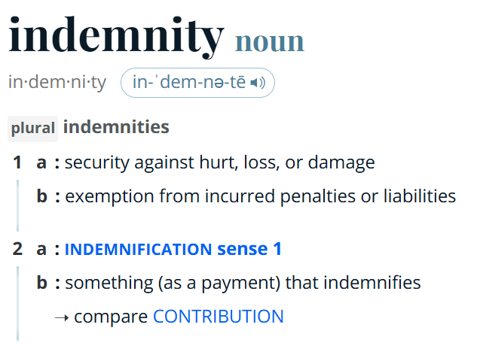
In my own words, indemnity in relation to hospitals is using definition #2. It’s not an insurance plan, but it’s not a savings account. It’s more of a safety net. You never know when you will need this plan.
The purpose of plan is to provide a person with money in case of hospitalization. In how it’s a safety net, it’s there when you need it.
In terms of how it works, it would be better to compare it to a savings account in functionality:
Hospital Indemnity | Savings Account
Pay a flat amount per paycheck | Varies as needed
Does not accrue interest | Accrues interest
Pay flat amount upfront | Can only withdraw amount in the account

For example, a person employed for a year for a company needs hospitalization. They enrolled in a hospital indemnity plan with a rate of $10,000. Their paycheck is bi-weekly and they pay $2.50 every paycheck. Comparing what that placed into a savings account from scratch at the same time:
Bi-weekly = 26 pays
$2.50 * 26 = $65.00
At the end of the year, when the person needs to use the plan, the hospital indemnity will pay the $10,000 upfront for usage as needed. A person using a savings account in lieu of the hospital indemnity plan, will only have $65.00 plus the interest accrued based on the interest rate the account is paying.
A person enrolled in a hospital indemnity plan can gain a sense of peace of mind the savings account owner does not.
I think the best way to describe what the hospital indemnity plan does is the AFLAC ad with Yogi Berra at the barber’s shop.


Figure 1: Photograph of two men sitting in barber chairs inside a barbershop, with Yogi Berra wearing a white barber cape and the other man reading a newspaper. Yogi states "And they give you cash, which is just as good as money" as he talks about AFLAC.
The quote that best explains the plan is “And they give you cash, which is just as good as money.”
The only issue I have about that old add is it talks about being hospitalized but never using the actual term of “hospital indemnity.” I don’t recall that term, that’s for sure.
Confusion about the plan can come from the documentation an employer offers to its employees to better understand their benefits.

From my own last benefits guide:
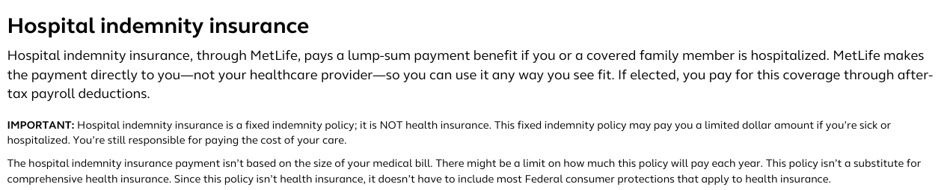
Figure 2: Hospital indemnity insurance benefits guide description.
This document flat tells you what the plan does. It even tells you it’s an after-tax deduction.
Looking at the information document to submit the claim:
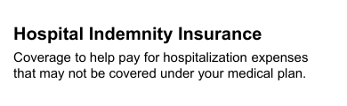
Figure 3: Coverage to help pay for hospitalization expenses that may not be covered under your medical plan.

To be fair to my employer, I am looking at coverage companies in their descriptions of the hospital indemnity plan. To note, these were all found via a search on Google and were not a carrier or broker.
Chevron:
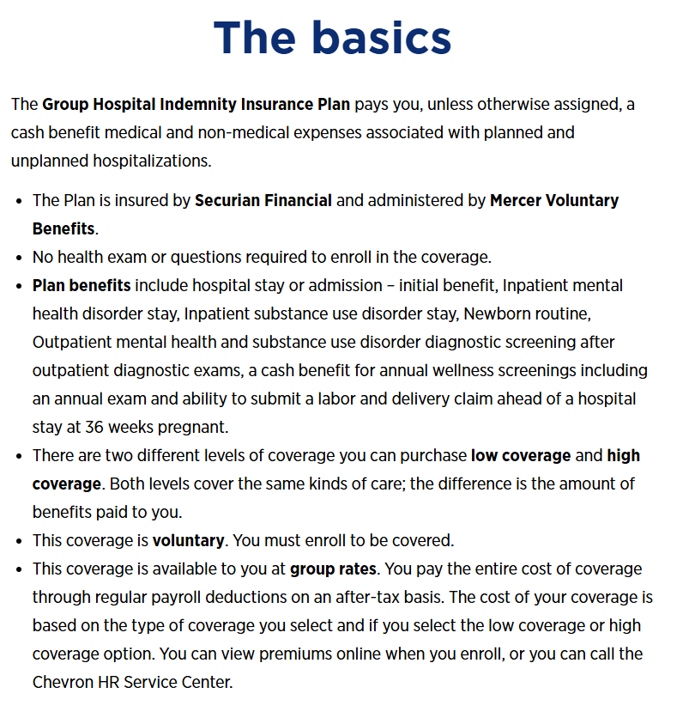 | Explaining the fact it pays a benefit is useful. My concern is the line about plan benefits. I think better wording would be “benefit paying events.” What are being described are events and not benefits.  It does mention it’s an after-tax plan.

Augusta University:
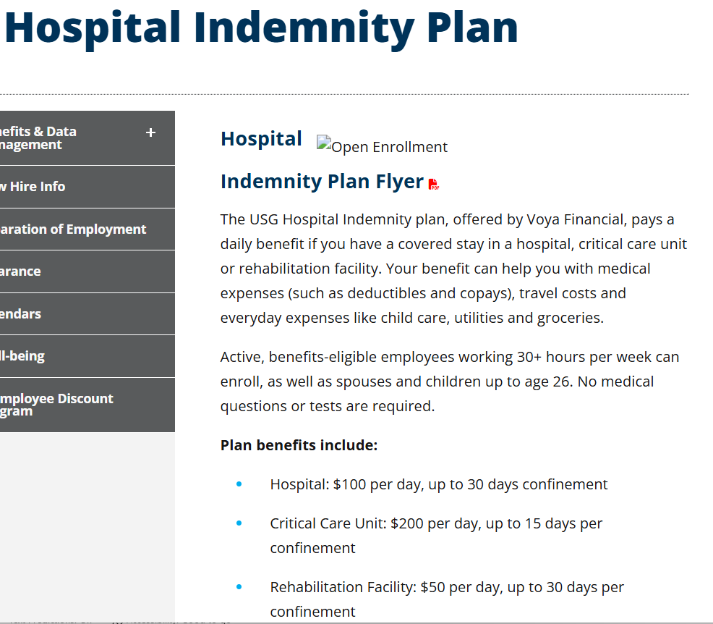 | AU just transfer several of their pages to the University System of Georgia website. As a result, some links and images have not been updated properly. *  Also broken is the link to the plan flyer.

Catholic Health:
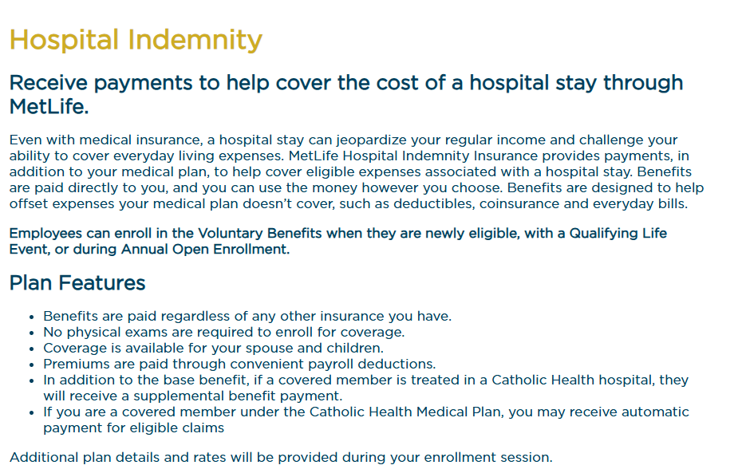 | Catholic Health has a robust and clean description. They tell you what it does, when it applies, and even when enrollment is available.

Overall, Hospital Indemnity is one plan that doesn’t have a standard description among carrier, nor employers. Plan descriptions can convey the message of “money while hospitalized,” they don’t fully stress how the plan is powerful.

